**Steps to creating a new ruleset**

**Rule Set Selection**

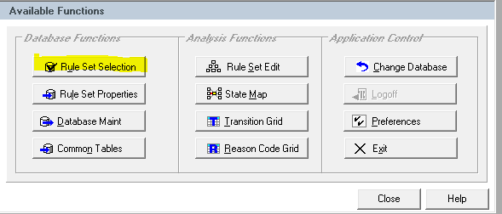

***Rule Set Options*: Add New Rule Set**

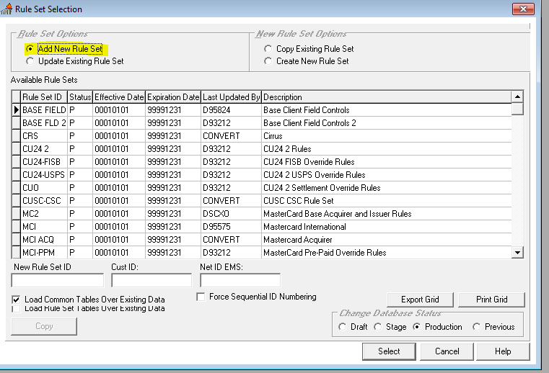

***New Rule Set Options:* Create New Rule Set**

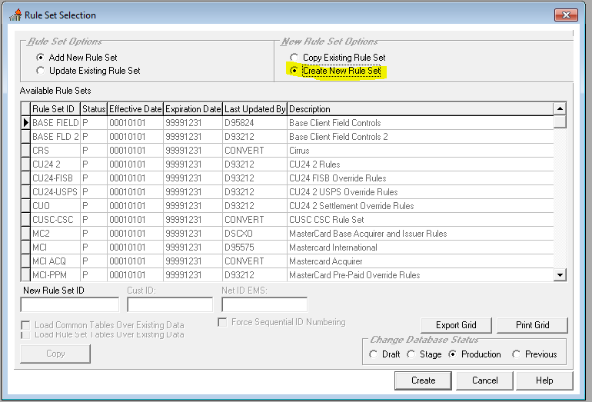

**New Rule set ID: RCN**

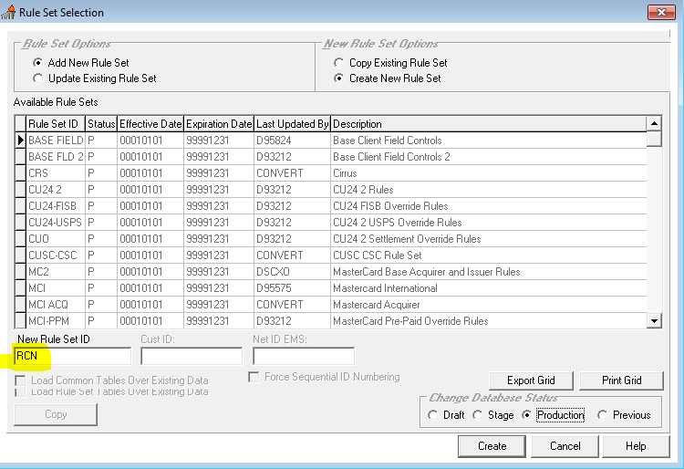

**Click Create button**

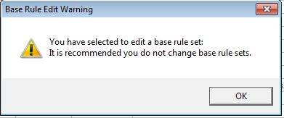

**Click OK.**

(This is a a warning about changing base rule sets. We are just using the base rule set as the parent for new RCN Rules. We will not be changing the base rule set.)

**Rule Set Table Edit screen will display**

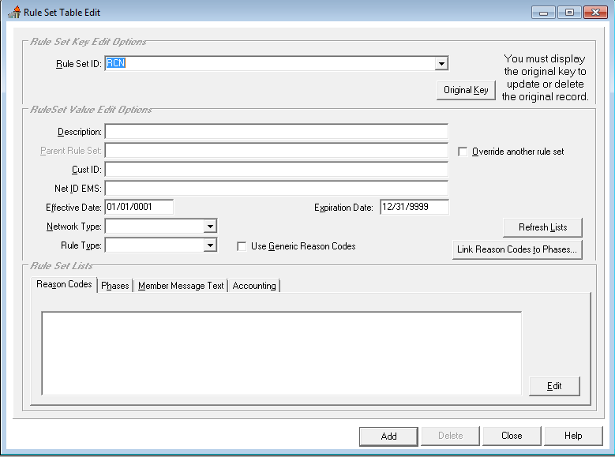

**Add description for RCN Rules**

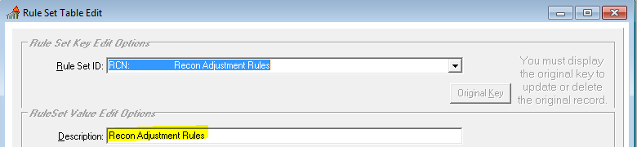

**Select Override another rule set**

**Parent Rule Set: BASE FLD 2**

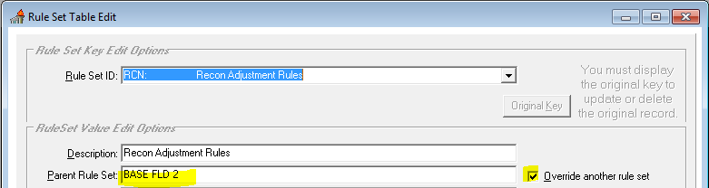

**Add Cust ID: CUSA (COOP will be the only customer using RCN Rules. Therefore, we add CUSA)**

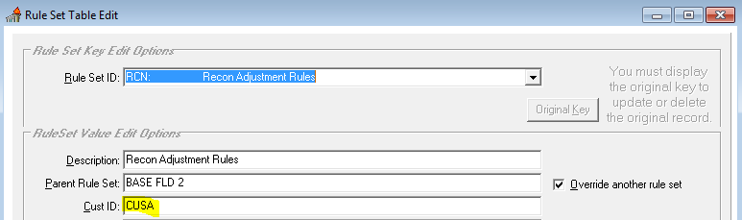

**Add NET ID EMS: RCN**

**(This field corresponds to the NET ID EMS in net rule use. However, we are not making any net rule use changes at this time for this project. This is actually a new case type.)**

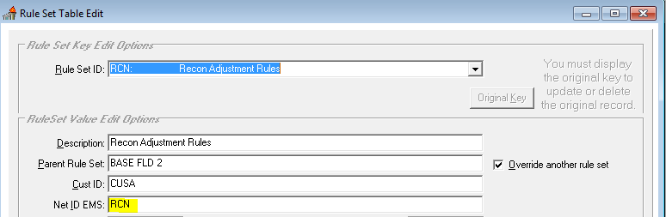

**Network Type: Regional (National is only used for Visa and MasterCard)**

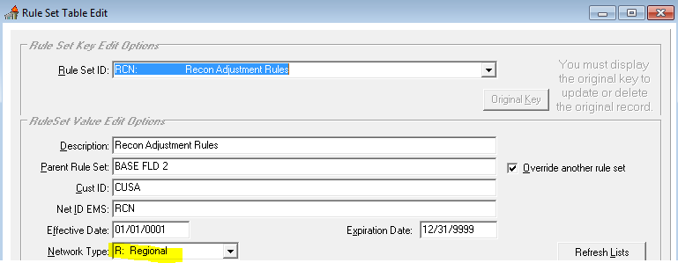

**Rule Type: Pin Based (Signature Based is used only for Visa and MasterCard)**

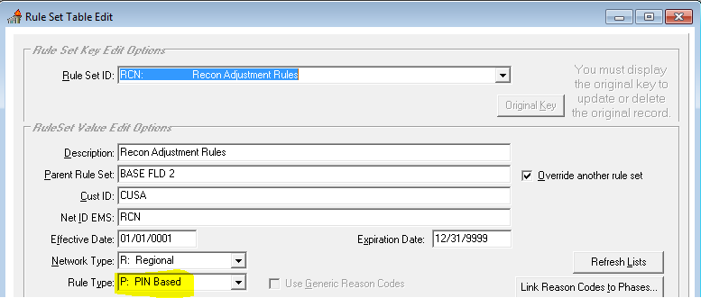

**Click Add button**

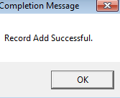

**Click OK**

**At this point, only web edits (INIT/TEMP) inherited from BASE FLD 2 Rules are in RCN**

**Rules**

**Reason Codes will have to be added**

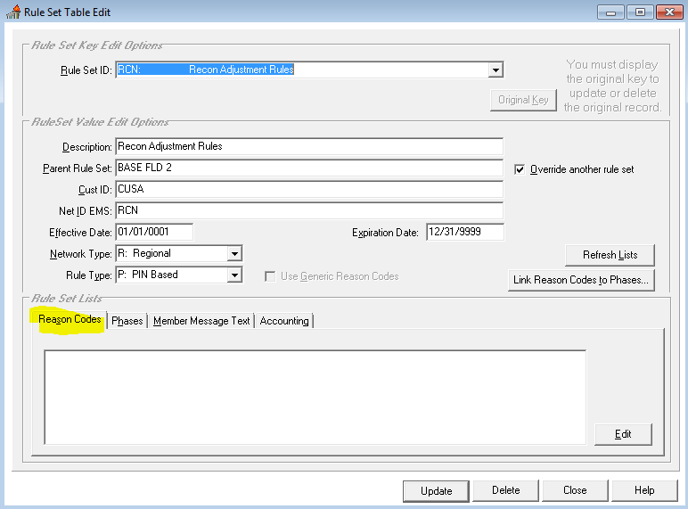

**The Recon-specific phases and transitions will have to be added**

